Worktag (PG/DD):
Date: Nov. 18th, 2019
Note: Receipt of payment for reservation at Ibis Rotterdam City Centre for program guest, name, for evening of Nov. 23rd. Used T&H Card to make reservation, which is noted in the “Guest Deposit” line item below.
Receipt:

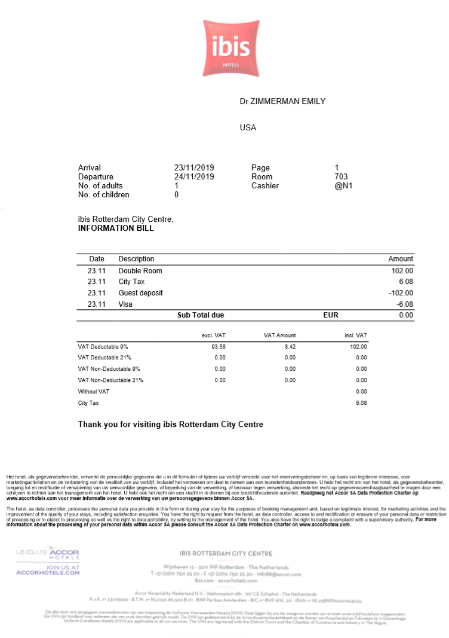

Date: Nov. 20th, 2019
Note: Receipt of payment for lunch in the Des Moines airport at Arugula and Rye. Used personal debit card for this transaction.
Receipt:

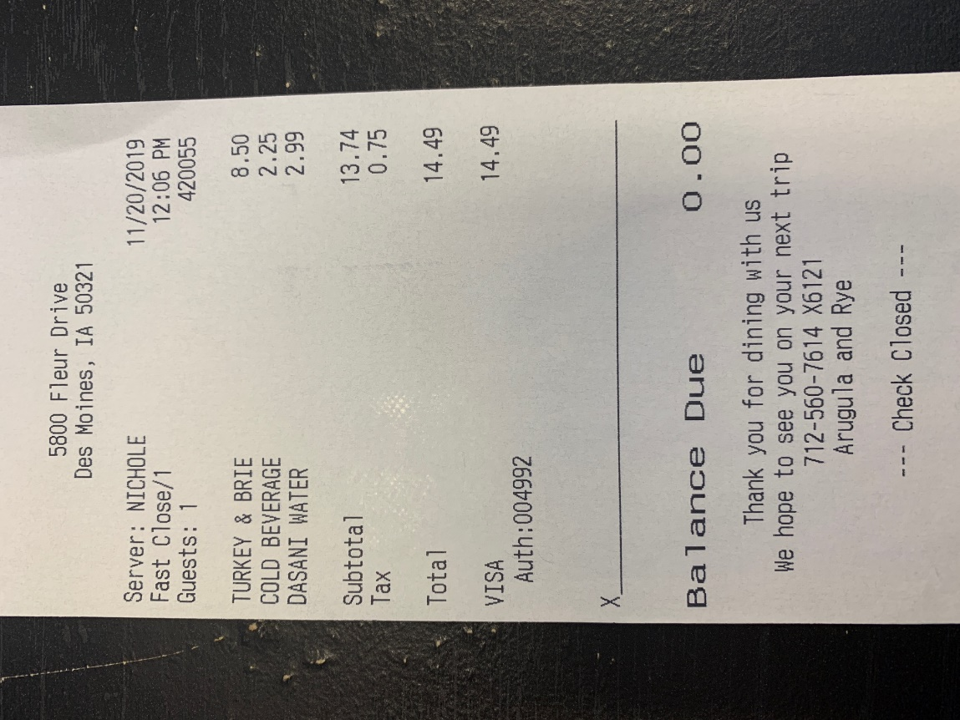

Date: Nov. 20th, 2019
Note: Receipt of payment for dinner in the Detroit airport at Paradies Lagardere - DTW. Used personal debit card for this transaction.
Receipt:

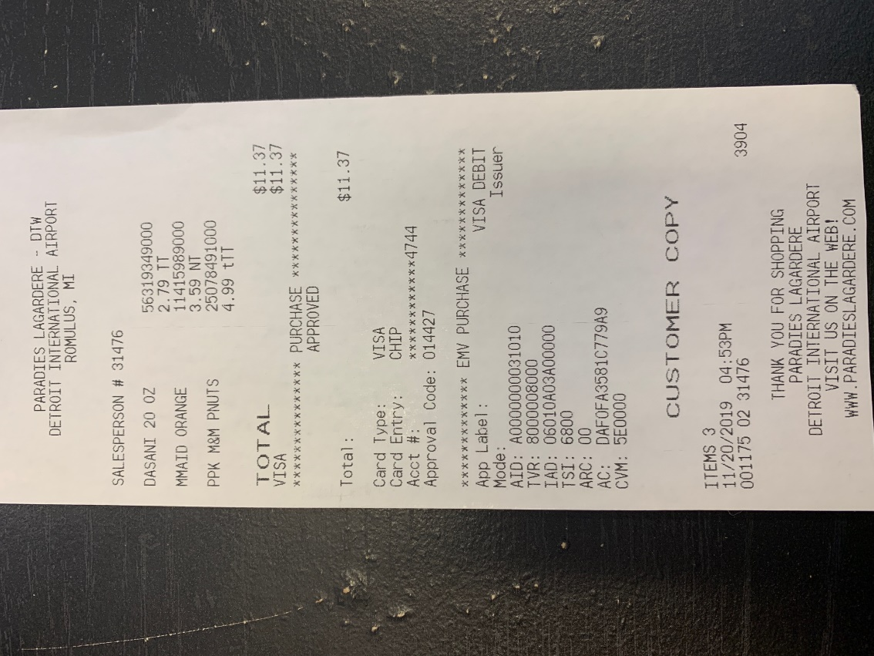

Date: Nov. 21st, 2019
Note: Receipt of payment for group meal (16 students + 2 faculty) at Haje in The Netherlands for lunch. Used event card to pay for the meal.
Receipt:

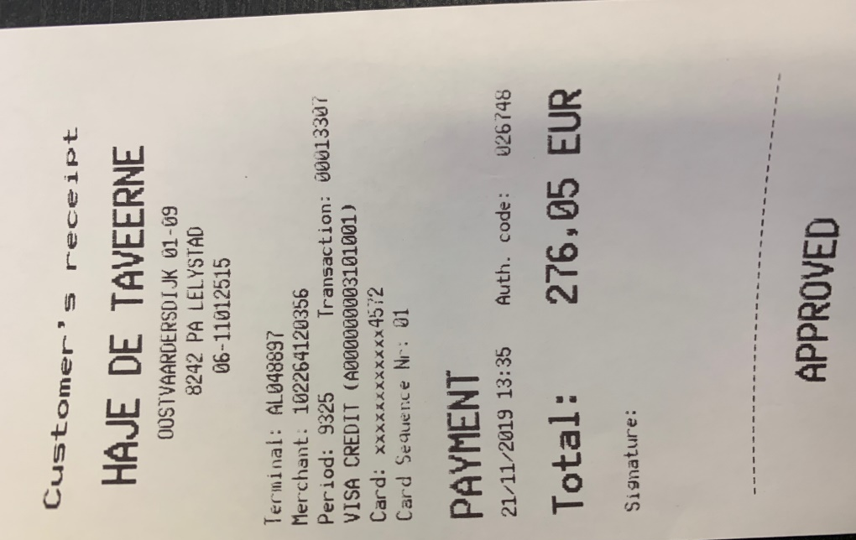
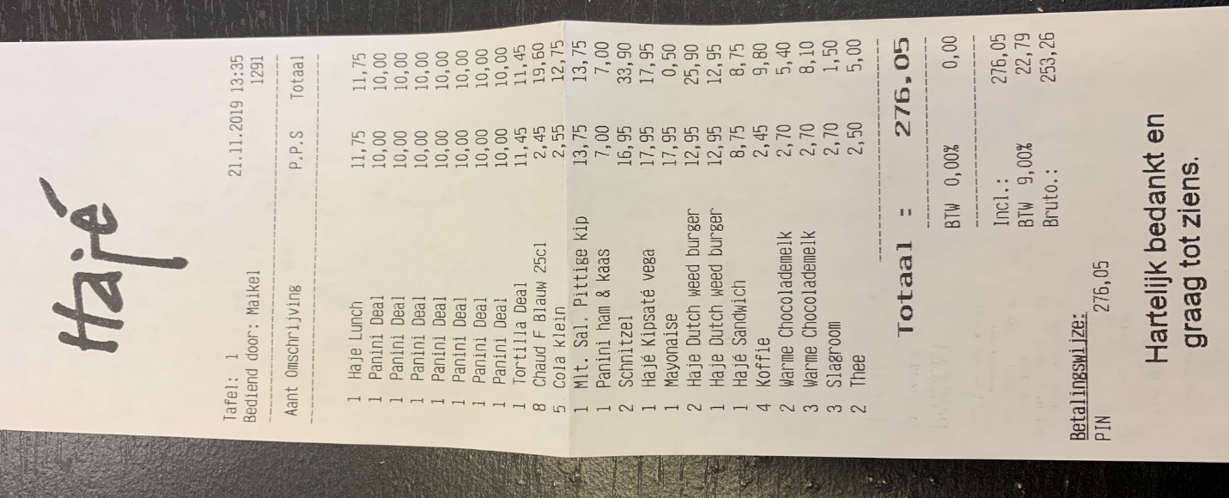

Date: Nov. 21st, 2019
Note: Receipt of payment for personal dinner at the hotel (Ibis Amsterdam City Centre). Used personal debit card to pay for meal. Please note that the itemized receipt shows (2) fish and chips and (2) sparkling waters for a total of 42 EURO. I paid for my ½ (1 fish and 1 sparkling water) with my personal card as noted on the charged receipt.
Receipt:

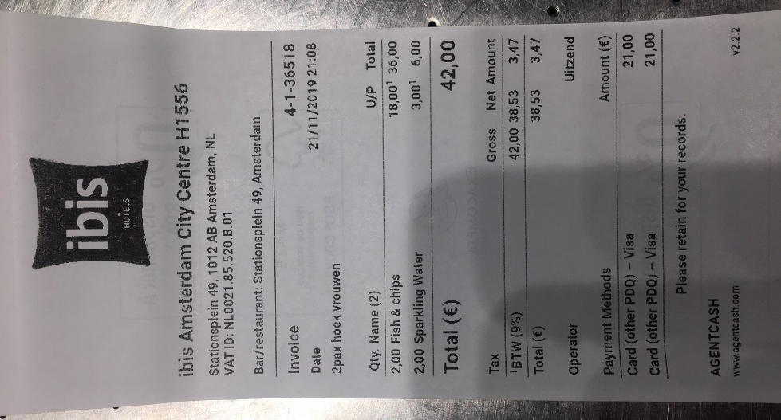
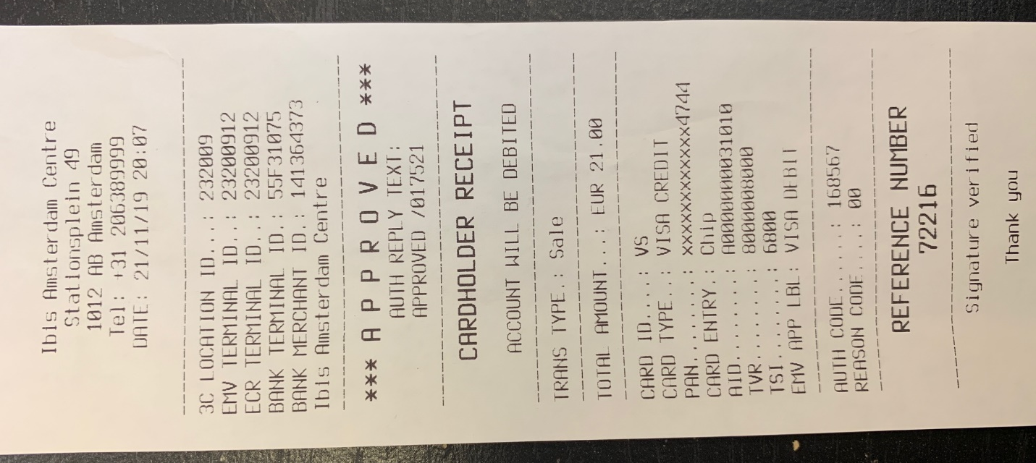

Date: Nov. 22nd, 2019
Note: Receipt of payment group dinner of 7 students (names), 1 guest (name), and 2 faculty (names). Used the Event card to pay for this meal.
Receipt:

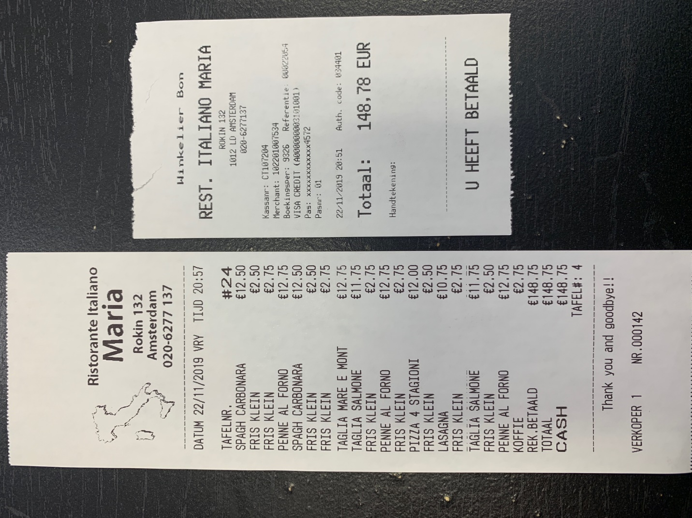

Date: Nov. 22nd, 2019
Note: Receipt of taking out 400 EURO of cash from ATM to be used for student lunch and dinners. Used the Event card to take the money out.
Receipt:

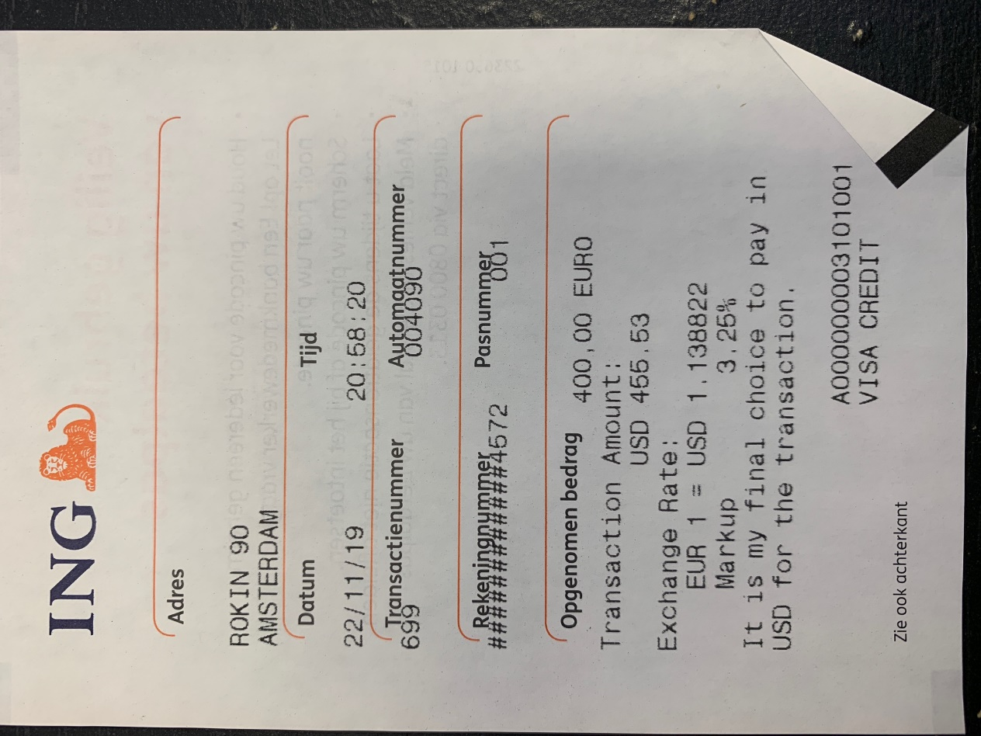

Date: Nov. 23rd, 2019
Note: Receipt of payment for City tax portion of the bill at Ibis Rotterdam City Centre for program guest, (name), for evening of Nov. 23rd. Used her personal debit card to pay for the city tax portion of the bill, which is noted below. Had already paid the guest deposit using T&H card on Nov. 18th.
Receipt:

Date: Nov. 23rd, 2019
Note: Receipt of payment for dinner for 1 student (name), 2 guests (names), and 2 faculty (names). Used the Event card to pay for dinner.
Receipt:

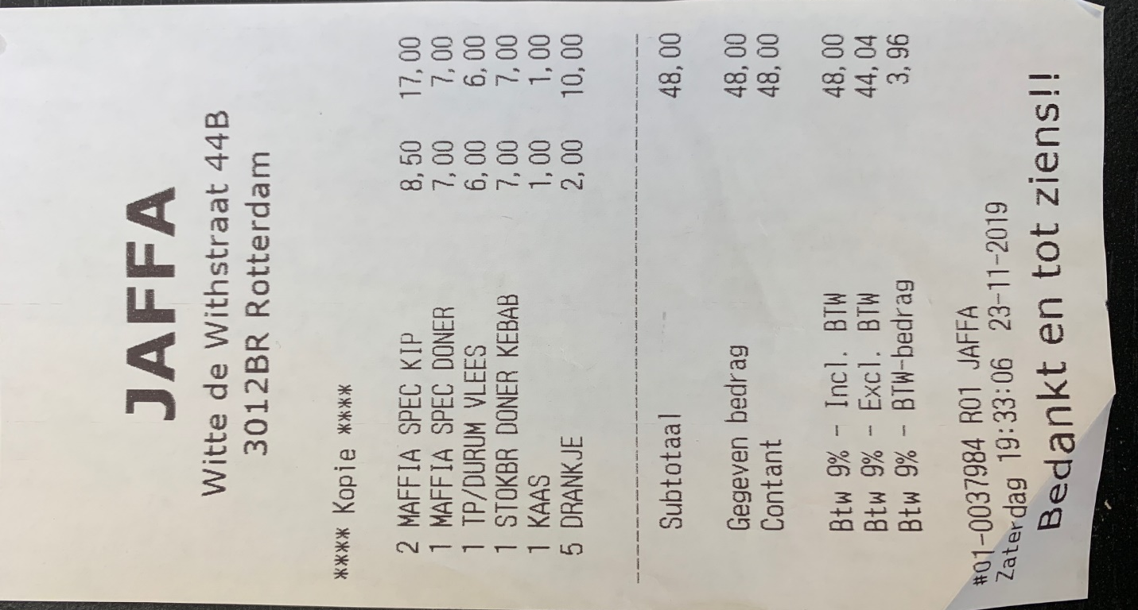

Date: Nov. 24th, 2019
Note: Receipt of payment for lunch for self. Used personal debit card to pay for this meal.
Receipt:
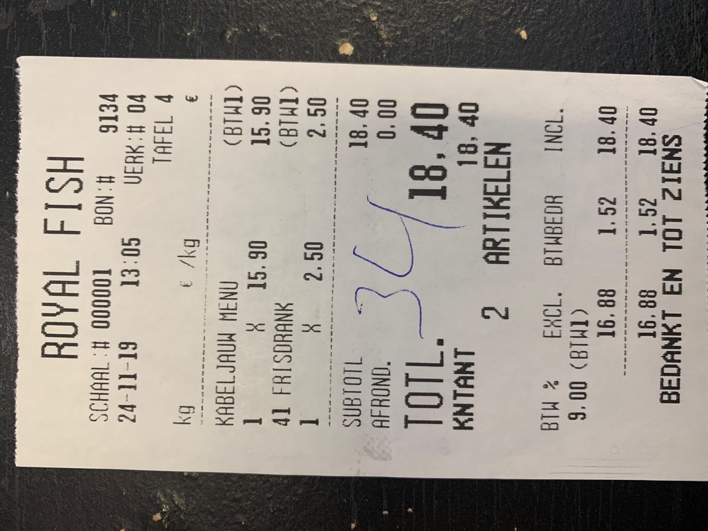

Date: Nov. 24th, 2019
Note: Receipt of payment for student disbursement of ATM cash for lunches. Disbursed 250 EURO to students for lunch meals. Signatures indicate receiving of money by each student.
Receipt:

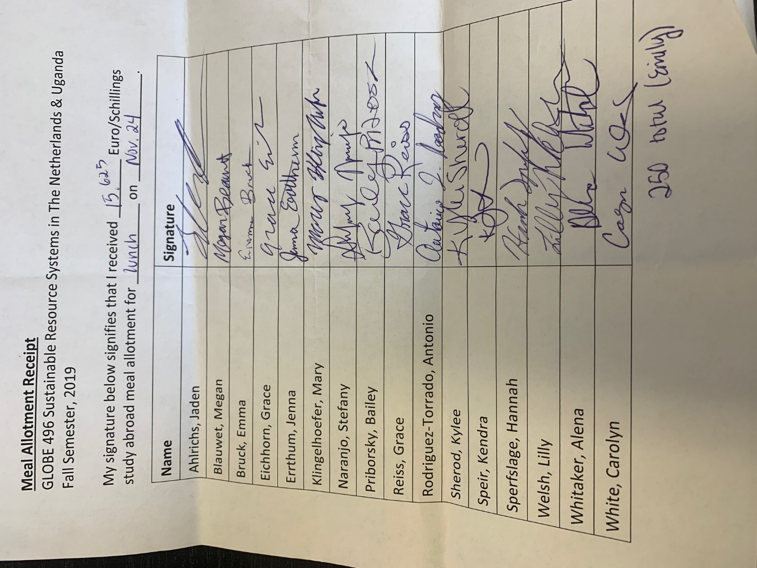
Date: Nov. 24th, 2019
Note: Receipt of payment for student disbursement of ATM cash for dinner. Disbursed 150 EURO to students for dinner meals. Program Director #2 disbursed the remaining 40 EURO. Signatures indicate receiving of money by each student. Program Director #2 will also file receipt for her portion.
Receipt:
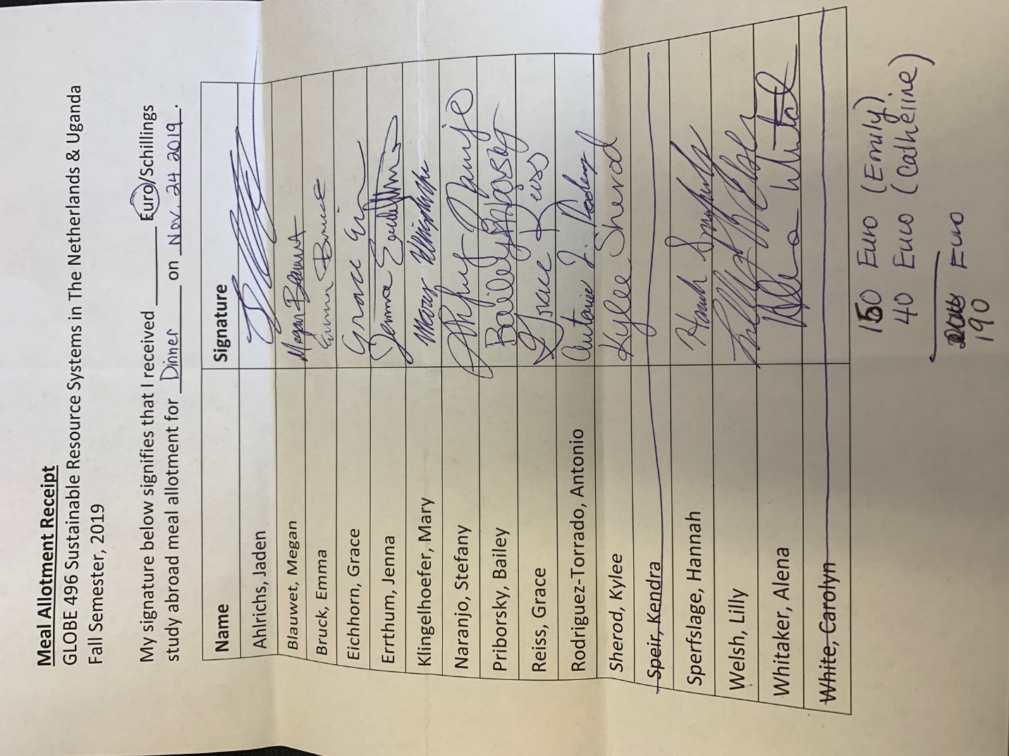

Date: Nov. 24th, 2019
Note: Receipt of payment for dinner for 2 students (names) and 2 faculty (names). Used Event card to pay for this meal.
Receipt:
